NDIS BUSINESS ENABLING STUDY
Should you start an NDIS provider business in Victoria?
Version | v2.0.0 (baselined)
Date | 20 August 2026
Prepared for | Zaid Al Dabbag
Jurisdiction | Victoria, Australia
Project class | STANDARD (GOV-A1.8, classified by Zaid at intake)
Governance | AI Project Governance Standard v3.9 with the v4.0 Business Layer (7 September 2026)
Currency of facts | Every external figure was verified on 20 August 2026 and is stale after 20 August 2027 (GOV-F1.16)
Produced by | AI under governance. Run record RUN-001. Seven sub-agents: five research, two independent verification.
Status | Delivered for decision. Not yet accepted — acceptance is recorded in the transfer pack.

THIS IS NOT ADVICE
This study is decision support. It is not legal, financial, tax or migration advice, and it is not a substitute for a lawyer, an accountant or the NDIS Commission. Where a figure would materially change your decision, the study names the action that would confirm it rather than asking you to trust the number.

1. The decision, on one page
The short answer. Yes, there is a viable business here — but it is not the one your earlier files described, the numbers are roughly double, and the model that actually works is probably not core supports.
Five findings that change the picture
# | Finding | Why it matters
1 | The unregistered route into core supports closes in July 2027. | The NDIS Amendment (Securing the NDIS for Future Generations) Bill 2026 passed Parliament on 19 August 2026 — the day before this study. It extends mandatory registration to personal care and daily living supports from July 2027. Verification registration takes four to six months. You have roughly eleven months, so the application starts in month one, not month six. [SRC-014, SRC-015, SRC-021]
2 | Gross margin is $21.30 an hour. Pay someone else to do the paperwork and it becomes $6.70. | At 0.40 administration hours per billable hour it is NEGATIVE $2.07. This is the arithmetic behind the sector finding that about half of NDIS providers were loss-making in 2024-25. The price is not the problem. The administration load is. [SRC-002, SRC-009, SRC-046, ASM-008]
3 | Capital at risk is about $15,875, not the $15,000 to $30,000 your earlier plan assumed. | That is one-off setup of about $10,791 plus six months of fixed costs, and it assumes you draw NOTHING. Add a $6,000 a month drawing and the six-month figure is about $51,875. [SRC-025 to SRC-041; ASM-005, ASM-006, ASM-012, ASM-014]
4 | Working capital was missing from the earlier plan entirely. | At 300 billable hours a month the wage bill is $15,684. Wages fall due before invoices are paid, so about $7,319 must sit behind the wage cycle permanently at a 14-day lag, and about $15,683 at 30 days. This is separate from setup capital. [REQ-SYS-11, ASM-007]
5 | Support coordination scores higher than core supports, on a third of the capital. | Delivered by you personally at 55% utilisation it returns about $98,664 a year on about $3,673 of setup, with no wage cycle and no working-capital gap. Its mandatory registration is currently PAUSED. The catch is in finding 6 below. [SRC-005, SRC-018, ASM-013]

6. AND THE ONE THAT STOPS ME DECIDING IT FOR YOU
Support coordination is the single service line the NDIS Review recommended restructuring into a "navigator" model. That design and pilot work runs through 2026 to 2028 and the funding mechanism is intended to change. So the trade study's winner is also the option government has publicly said it intends to redesign. On the weights I set, support coordination scores 3.70 against core supports at 3.30. Raise the weight on regulatory stability from 25% to 40% and it flips: 3.40 against 3.45. That is a genuine coin-toss on a weight only you can set, so under GOV-B6.4 I escalate it rather than decide it. [SRC-049, DEC-003, RSK-003]

What I recommend
- PROCEED to a decision, not to a bank transfer. Four things (ACT-005 to ACT-008) cost you nothing but phone calls and would collapse the widest uncertainty bands in this study. Do those first.
- If you go, START THE REGISTRATION APPLICATION IN MONTH ONE regardless of which service model you choose. The July 2027 clock does not care that you are still deciding, and being registered before your unregistered competitors are forced out is the strongest single advantage available to you (RSK-010).
- DO NOT start with SIL or SDA. Mandatory registration for it is already in force, certification audit runs nine to twelve months, and national SDA sits at 53.7% utilisation against a surplus of 4,638 places [SRC-050].
- TREAT THE ADMINISTRATION QUESTION AS THE BUSINESS. Whether you personally do the rostering, notes and invoicing is worth more to the outcome than the price of anything you will buy.
FOUR THINGS I NEED FROM YOU BEFORE THIS STUDY CAN GIVE YOU A NUMBER
ACT-001 [ASM-011] Will you run this yourself full time, or fund it and employ a manager? If you do the work and the administration yourself, break-even is about 40 billable hours a month. If you employ a manager on about $95,000 a year instead, it is about 411 — roughly ten times the volume.
ACT-002 What must you draw from the business each month, and from when? Every scenario in this study currently assumes you work for nothing.
ACT-003 What is the maximum you are willing to lose entirely? I can tell you what it costs; I cannot tell you whether it is affordable for you.
ACT-004 Do you or a co-founder hold relevant qualifications or disability-sector experience? Support coordination's score depends on you being able to bill personally.

2. What changed from your earlier files
Your project folder held four working files. Under GOV-F8.8 every figure in them is a defect, because none carried a source. That was raised as DEF-001 and the files were archived to 06_Archive/_versions and moved to 04_Inputs/legacy_unsourced. They are kept as evidence of what was believed, not used as inputs. Here is what was actually wrong.
What the earlier files said | What the sourced position is | Source
Budget of $15,000 to $30,000 to clear the startup phase [unsourced in the legacy files — DEF-001] | About $15,875 of business cash for six months with zero drawings, or about $51,875 if you draw $6,000 a month. Working capital of $7,319 to $15,683 sits on top of both. | Financial Model
Audit $900 to $1,800 for verification, $3,000 to $15,000+ for certification | No Approved Quality Auditor publishes a fee at all. Global-Mark and GCC both state the fee varies by registration groups, participants, outlets and workers and require a quote. The only figures available are a consultancy's market estimate: $3,500 to $6,000 verification, $6,000 to $12,000 certification. | SRC-034, SRC-035
Registration takes 3 to 9 months | Verification 4 to 6 months; certification 9 to 12 months, end to end. | SRC-021
Set up a PRODA account | PRODA is being retired for NDIS Commission portals. Transition to myID plus RAM runs to 30 September 2026, after which PRODA cannot access those portals. The principal authority needs myID Strong, which requires a passport. | SRC-030
Nothing on mandatory registration | Mandatory registration commenced for SIL and digital platform providers on 1 July 2026, and reaches personal care and daily living supports from July 2027. This is the single most consequential omission. | SRC-014 to SRC-017
Nothing on working capital [ASM-007] | Wages fall due before claims are paid. At 300 billable hours a month that gap is $7,319 at a 14-day lag. | REQ-SYS-11
Nothing on the administration burden | It is the difference between a $21.30 margin and a $6.70 one, and at 0.40 hours it turns the margin negative. | ASM-008, SRC-046
ASIC Pty Ltd registration $636 | Still $636 — the one figure that survived. Carried at Medium confidence because the primary ASIC fee page would not render and a secondary summary was used. | SRC-025
Table 2.1 — DEF-001 corrections. One of eight material figures survived contact with a source.

3. The regulatory position as at 20 August 2026
This section is the reason the study exists. The NDIS registration regime changed materially in the eight weeks before this study was written, and it changes again in July 2027.
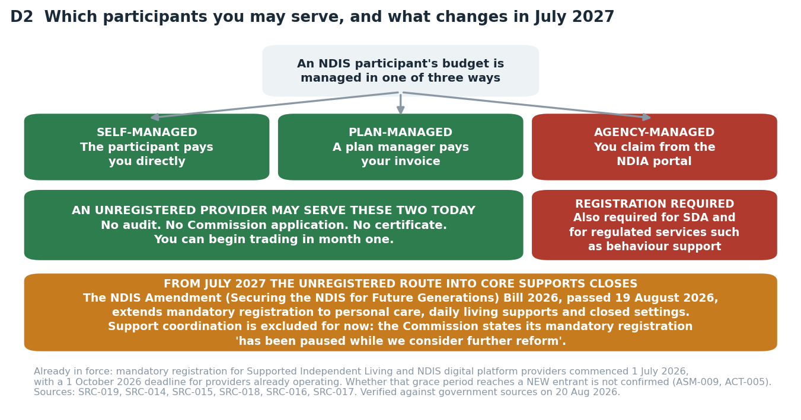
D2 — Which participants an unregistered provider may serve, and what July 2027 does to that.

3.1 What is settled law
Position | Detail | Confidence
Unregistered providers may serve self-managed and plan-managed participants | They may not deliver NDIA-managed supports, SDA, or regulated services such as behaviour support. Verified against a primary government source. [SRC-019] | High
Mandatory registration is in force for SIL and digital platform providers | The regime commenced 1 July 2026. Providers ALREADY OPERATING have until 1 October 2026 to be registered or have an application in progress. [SRC-016, SRC-017] | High
Mandatory registration of support coordination is PAUSED | The Commission's own words: "Mandatory registration of support coordination has been paused while we consider further reform." [SRC-018] | High
36 registration groups; 13 need certification audit, 23 need verification | An application spanning both defaults to certification for the whole application. Choose your registration groups carefully — one certification group drags everything with it. [SRC-020] | High
The 2026 Amendment Bill passed Parliament on 19 August 2026 | It extends mandatory registration to personal care, daily living supports and supports in closed settings from July 2027. Royal Assent is a separate step that was not yet confirmed at the time of writing. [SRC-014, SRC-015] | High for passage; Medium for the July 2027 scope
Table 3.1 — Independently verified by agent V1 against primary government sources. Trade press was used to locate facts but never to confirm one.
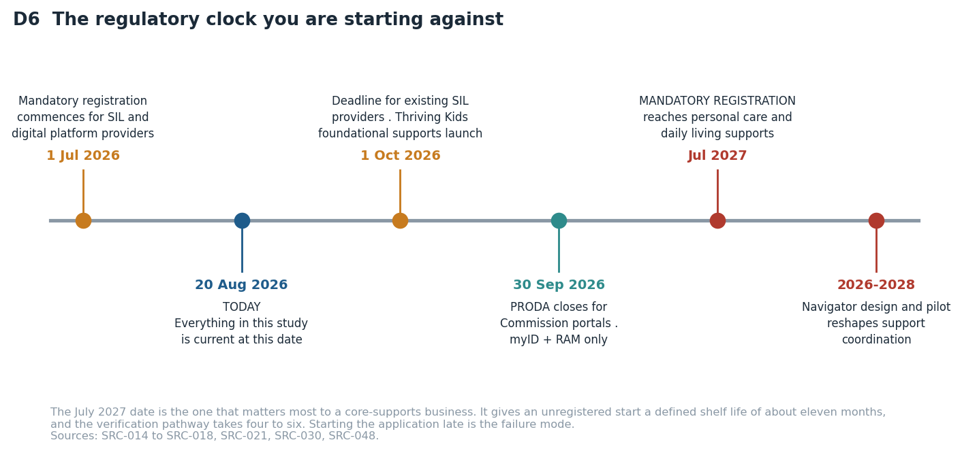
D6 — The regulatory clock. The July 2027 date gives an unregistered core-supports start a defined shelf life.

3.2 What is NOT settled, and what it costs you
- Whether the 1 October 2026 SIL grace period reaches a NEW entrant or only incumbents. It decides whether SIL is open to you at all this financial year. Recorded as ASM-009; ACT-005 resolves it with one phone call.
- Whether the NDIS Commission charges its own application or certificate fee. One consultancy asserts it does and publishes no amount; no government page confirms or denies it. Recorded as ASM-010; ACT-006 resolves it.
- The "staged implementation to July 2028" detail of the Amendment Act. The July 2027 start and the three target service groups are confirmed; the 2028 staging is not, because the government fact sheet blocks automated reading.
- What the navigator model will do to support coordination. The recommendation and the 2026-2028 pilot are documented; the final design is not. This is RSK-003 and it is the reason section 7 escalates rather than decides.

4. What it takes to operate in Victoria
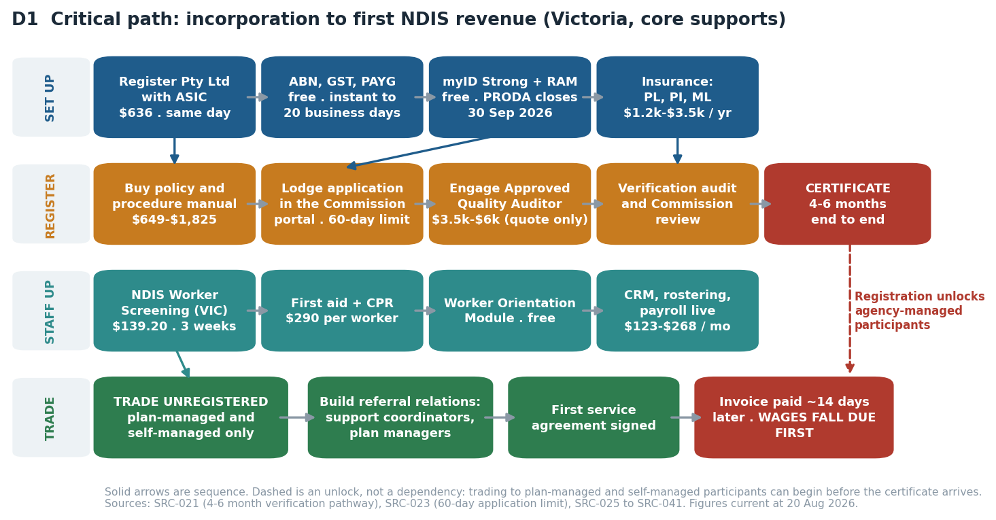
D1 — Critical path from incorporation to first revenue. Note the dashed line: trading can begin before the certificate arrives.

4.1 Every obligation, with its authority, cost and lead time
Obligation | Authority | Cost | Lead time | Source
Pty Ltd company registration | ASIC | $636 one-off | Same day online | SRC-025
Company annual review | ASIC | $342 per year | Annual statement | SRC-026
Business name, three years | ASIC | $108 | Same day | SRC-027
ABN | Australian Business Register | Free | Instant, or up to 20 business days if referred | SRC-028
TFN, GST, PAYG withholding | ATO | Free | With or after the ABN; PAYG before the first pay run | SRC-029
myID Strong (you) and myID Standard (staff), plus RAM | Australian Government | Free | Minutes. PRODA closes for Commission portals 30 Sep 2026. myID Strong needs a passport | SRC-030
NDIS Worker Screening Check | Victorian NDIS Worker Screening Unit | $139.20 per person, valid 5 years | Up to 3 weeks, longer if manual | SRC-031
Working with Children Check | Victoria (Worker Screening Act 2020) | $139.20 employee, free for volunteers | Not separately confirmed | SRC-032
WorkCover registration | WorkSafe Victoria | Minimum premium $400 + GST; state average rate 1.8% of remuneration | Annual | SRC-012
Portable long service leave levy | Portable Long Service Authority (Vic) | 1.65% of ordinary pay; explicitly covers NDIS-funded work | Register as an employer | SRC-013
Public liability, professional indemnity, personal accident | Commercial insurers | $1,200 to $3,500 per year, indicative only | By quote. Management liability has NO published price | SRC-040
Policy and procedure manual | Commercial vendors | $649 to $1,825 verification-level | Immediate download | SRC-036
Verification audit | Approved Quality Auditor | $3,500 to $6,000 estimated. NO auditor publishes a rate card | Within the 4 to 6 month registration window | SRC-034, SRC-035
First aid HLTAID011 and CPR HLTAID009 | Registered training organisations | $195 and $95 per person, from | Book a course | SRC-041
Worker Orientation Module | NDIS Commission | Free | Online, self-paced | SRC-042
Disability worker registration | Victorian Disability Worker Commission | Free, and VOLUNTARY — it is not mandatory | N/A | SRC-033
Table 4.1 — REQ-SYS-06. Every row carries an authority, a cost and a source. Where a cost is indicative rather than published, the row says so.
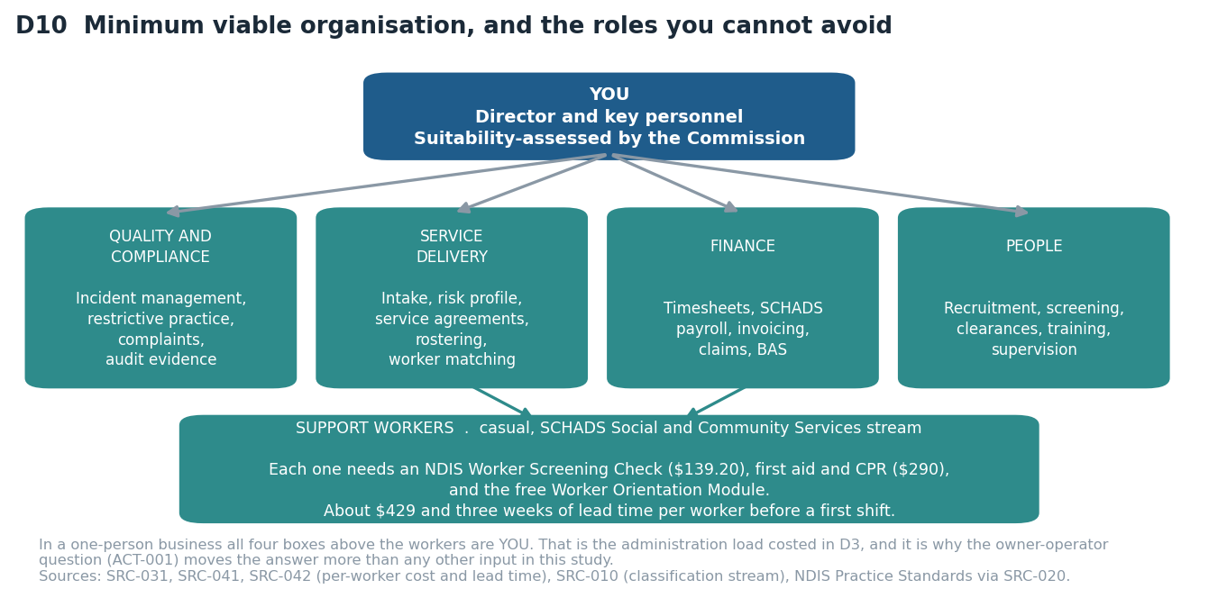
D10 — In a one-person business, all four role boxes are you. That is the administration load section 5 costs.

5. What it costs, and where the money actually goes
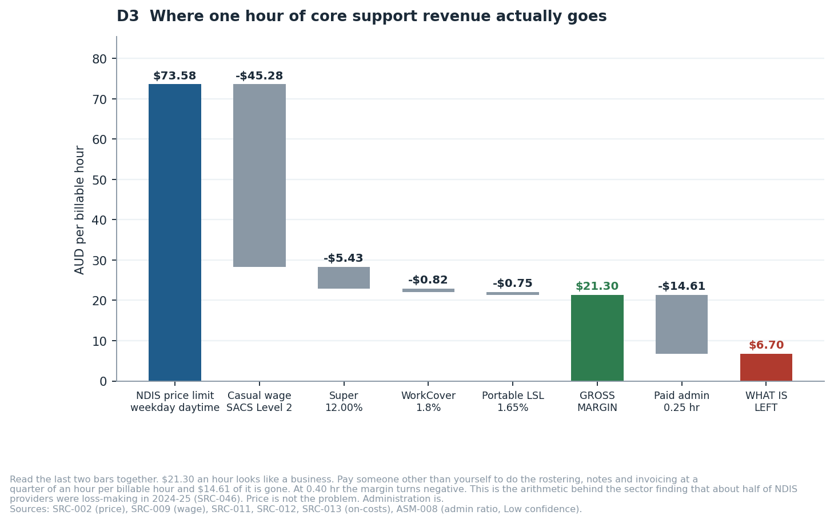
D3 — One hour of core support revenue, all the way down. Read the last two bars together.

5.1 Capital before first revenue
Scenario | One-off setup | Fixed cost per month | Six months with no revenue
Core supports, registering, three workers screened [Financial Model, Costs sheet; SRC-025 to SRC-041] | $9,110 to $12,786 (base $10,791) | $602 to $1,438 (base $847) | $15,875 with zero drawings
The same, drawing $6,000 a month [ASM-012] | as above | as above | $51,875
Support coordination, no registration, no workers [SRC-018; Financial Model, SupportCoordination sheet] | $3,673 | $847 | $8,757 with zero drawings
SIL / SDA supported accommodation [DEC-005; SRC-016, SRC-034, SRC-036] | Registration pathway only: about $8,600 to $16,900 (certification audit $6,000-$12,000 plus a certification-level policy manual $1,800-$3,700, plus company, insurance and worker costs as above) | as above, plus property | NOT MODELLED — see below
Working capital, on top of all of the above, once trading [ASM-007; REQ-SYS-11] | - | - | $7,319 at a 14-day payment lag; $15,683 at 30 days
Table 5.1 — REQ-SYS-01 and REQ-SYS-07. Full line-by-line build in the Costs sheet of the financial model. SIL and SDA are deliberately NOT financially modelled: no property parameters were supplied, and any figure for the property and 24/7 rostering side would be invention rather than estimation. The exclusion is recorded as DEC-005 and the work to close it as BKL-005 — it is a stated omission, not a silent one.
WHAT IS NOT IN THESE NUMBERS, BECAUSE NO PRICE IS PUBLISHED
The NDIS Commission's own application or certificate fee, if one exists (ACT-006). Management liability insurance — no published figure exists for a small Australian disability business (ACT-008). The mid-term surveillance audit at about eighteen months, estimated at 60 to 70 per cent of the initial audit fee. Payroll tax, if the business crosses the Victorian threshold. Income tax and GST remittance. A consultant, if you engage one to run the registration. Treat the capital figure as a floor with four named gaps, not as a complete estimate.

5.2 Where an hour of revenue goes
Line | Per billable hour | Note
NDIS price limit, weekday daytime | $73.58 | The ceiling, not a target [SRC-002]
Casual wage, SACS Level 2, including 25% casual loading | -$45.28 | [SRC-009]
Superannuation at 12.00% | -$5.43 | [SRC-011]
WorkCover at the 1.8% Victorian state average | -$0.82 | The sector rate may be higher [SRC-012, ASM-004]
Portable long service leave levy at 1.65% | -$0.75 | Victoria-specific, and the on-cost most often forgotten [SRC-013]
GROSS MARGIN | $21.30 (29.0%) | Before any overhead at all. This is not profit. [SRC-002 minus SRC-009, SRC-011, SRC-012, SRC-013]
Paid administration at 0.25 hours per billable hour | -$14.61 | A coordinator at SACS Level 3, fully loaded [ASM-008]
CONTRIBUTION IF ADMINISTRATION IS PAID | $6.70 | This is the row that decides whether the business works. [ASM-008 at 0.25 hr]
The same at 0.40 administration hours | -$2.07 | Every hour you sell would lose money. [ASM-008, Low confidence — the study's most dangerous input]
Table 5.2 — REQ-SYS-05. Independently re-derived by verifier V2, which found the first pass had omitted WorkCover and portable long service leave entirely (DEF-002) and corrected the loaded wage from $50.71 to $52.28.

6. Trade study 1: when to register
Under GOV-B6.1 a decision that changes approach must record at least two credible alternatives, the criteria and their weights fixed BEFORE scoring, the scoring, the sensitivity of the result, and the rationale. Both trade studies in this study meet that standard. The weights below were set on 20 August 2026 before any alternative was scored.

6.1 The alternatives
- A1 — Register first, trade second. Spend four to six months in the registration pathway, then open the doors to every participant including agency-managed.
- A2 — Trade unregistered to plan-managed and self-managed participants from month one, and run the registration application in parallel so the certificate arrives well before July 2027.
- A3 — Remain unregistered indefinitely. Eliminated on evidence, not on opinion: mandatory registration reaches personal care and daily living supports in July 2027, so this option has a known expiry date for a core-supports business (SRC-015).
Criterion | Weight | A1 Register first | A2 Trade and register in parallel | A3 Stay unregistered
Capital at risk before first revenue | 30% | 2 | 5 | 5
Addressable market | 25% | 5 | 3 | 3
Regulatory durability past July 2027 | 25% | 5 | 5 | 1
Operational burden | 20% | 2 | 3 | 5
WEIGHTED SCORE | 100% | 2.85 | 4.05 | 2.30
Table 6.1 — DEC-004. Weights timestamped 20 August 2026, before scoring. Scores out of 5.
Sensitivity. Not close. A2 leads A1 by 1.20 on a five-point scale. The result would flip only if addressable market were weighted above about 55%, which would require agency-managed participants to be your only viable client base. The evidence does not support that: plan-managed and self-managed participants are a large and immediately reachable market, and reaching them needs no certificate.
Decision. A2. Trade unregistered from month one while the verification application runs. This preserves cash during the four-to-six-month registration window and still clears the July 2027 gate — but only if the application is lodged early. Lodging it in month six leaves no margin.

7. Trade study 2: which service model
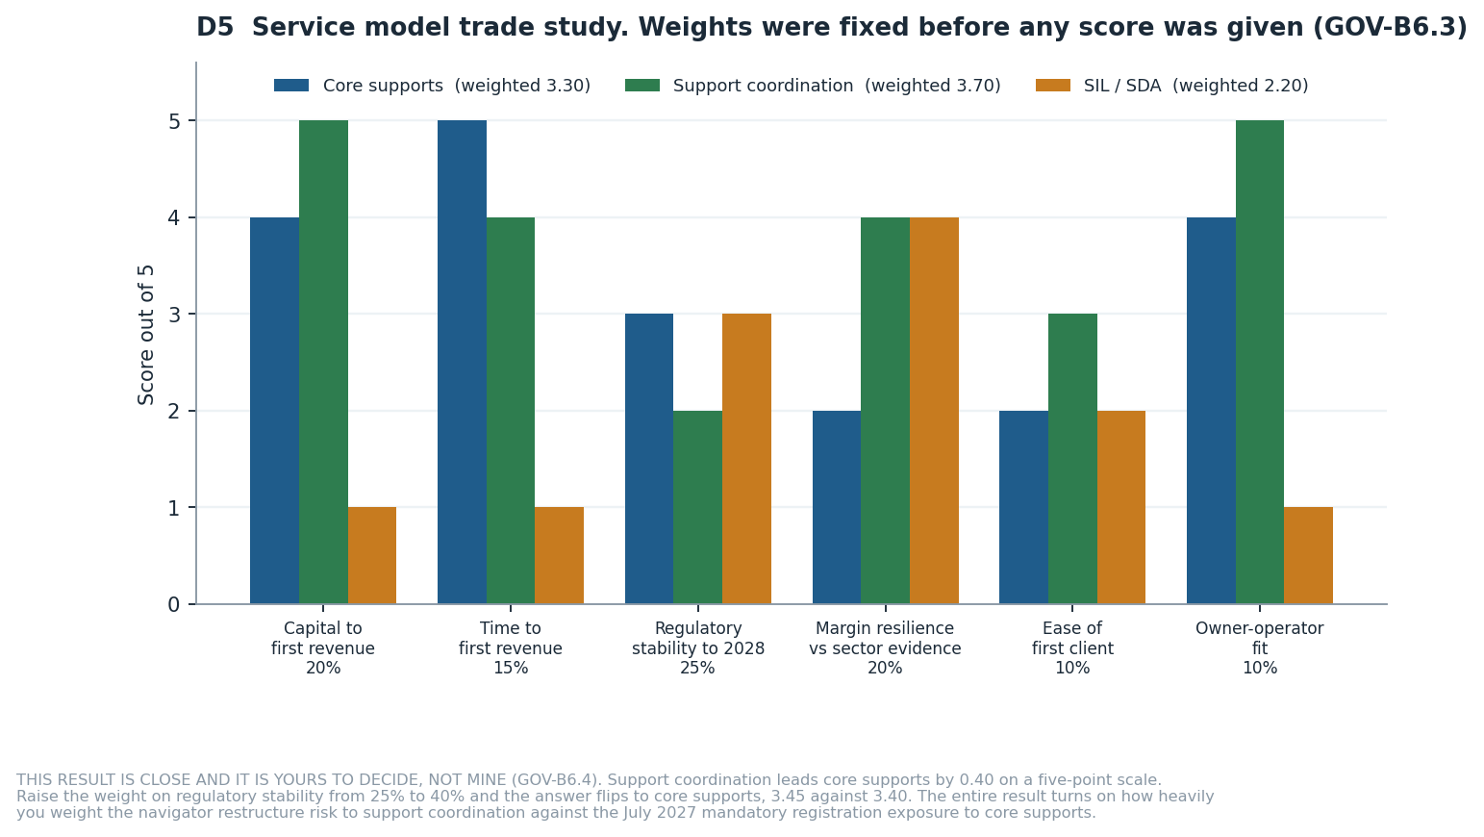
D5 — Weights were fixed before any score was given. The result is close and the sensitivity says so.
Criterion | Weight | Core supports | Support coordination | SIL / SDA
Capital to first revenue | 20% | 4 | 5 | 1
Time to first revenue | 15% | 5 | 4 | 1
Regulatory stability through 2028 | 25% | 3 | 2 | 3
Margin resilience against sector evidence | 20% | 2 | 4 | 4
Competitive intensity and ease of first client | 10% | 2 | 3 | 2
Owner-operator fit | 10% | 4 | 5 | 1
WEIGHTED SCORE | 100% | 3.30 | 3.70 | 2.20
Table 7.1 — DEC-003. Scores out of 5.
SENSITIVITY — AND WHY THIS ONE IS YOURS TO DECIDE
Support coordination leads core supports by 0.40 on a five-point scale. That is close. Raise the weight on regulatory stability from 25% to 40% and the answer flips to core supports, 3.45 against 3.40.
The whole result turns on one judgement: how heavily do you weight the risk that government redesigns support coordination into a navigator model, against the certainty that mandatory registration reaches core supports in July 2027? Both risks are real, both are documented, and neither has a settled end state. GOV-B6.4 requires me to escalate a decision this close rather than take it. So I am telling you the arithmetic and the weight that flips it, and leaving the weight to you.

7.1 The case for each
Model | The case for | The case against
Core supports — personal care and community participation | The largest addressable base. Fastest route to a first dollar. Low capital. You can deliver hours yourself while you build. And July 2027 removes your unregistered competitors, which is an advantage if you are already registered (RSK-010). | The thinnest margin of the three once administration is costed. A market fragmented across 269,000+ providers with none holding 5% share [SRC-045]. And about half the sector was loss-making in 2024-25 on these same economics [SRC-046].
Support coordination, optionally with plan management | [SRC-005, SRC-018, ASM-013] $100.14 an hour with no direct wage cost if you deliver it. About $3,673 of setup against about $10,791. No rostering fleet, no wage cycle, no working capital gap. Break-even at about 8 billable hours a month. Mandatory registration is paused. | It is the one service line the NDIS Review targeted for structural redesign, with design and pilot work running 2026 to 2028 and the funding mechanism intended to change. It also depends on you personally being credible to referrers — which is ACT-004, still unanswered.
SIL and SDA supported accommodation | [SRC-044, SRC-050] The largest packages in the scheme: Victorian SIL participants averaged about $479,800 a year against about $59,500 for non-SIL. Shift-sharing across co-residents multiplies margin per rostered hour. Genuinely the best margin structure of the three, once scale exists. | Mandatory registration already in force. Certification audit nine to twelve months. Property and a 24/7 rostered workforce before the first tenancy. National SDA utilisation at 53.7% against a surplus of 4,638 places [SRC-050]. Worst possible fit for a first-time owner-operator.
Table 7.2 — Sources: SRC-005, SRC-018, SRC-044 to SRC-050.
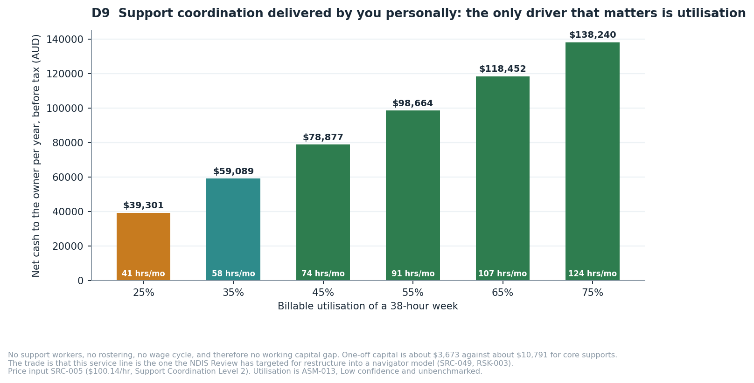
D9 — Support coordination delivered personally. Utilisation is the only driver that matters.
Decision on SIL and SDA. Excluded from the recommended path, but not permanently (DEC-005). Revisit after two years of trading, when you have compliance systems, a workforce and a balance sheet. The margin structure is real; you just cannot reach it from a standing start.

8. The financial picture
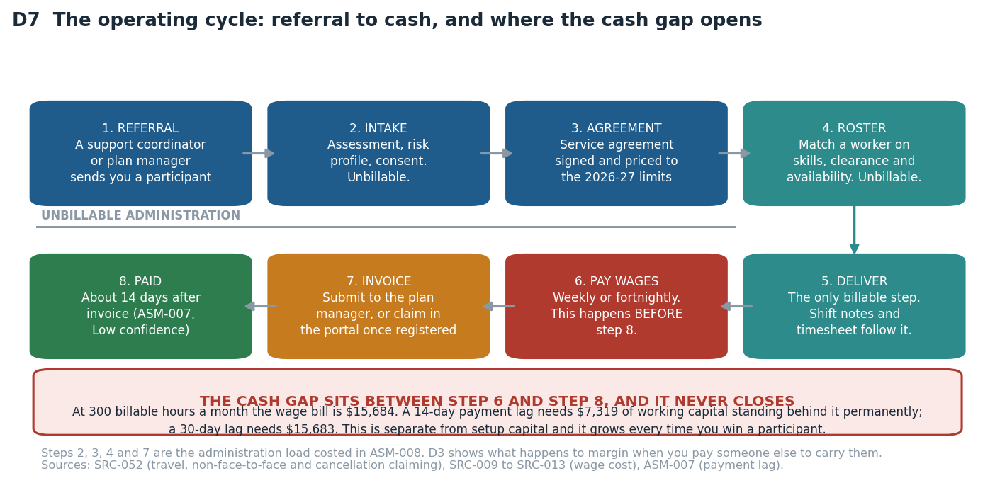
D7 — The operating cycle. Steps 2, 3, 4 and 7 are unbillable. Step 6 happens before step 8.

8.1 Break-even
Measure | You do the administration | Administration is paid
Contribution per billable hour [SRC-002, SRC-009, ASM-008] | $21.30 | $6.70
Break-even billable hours per month | 40 | 126
Roughly how many participants at 15 hours a week | about 0.6 | about 2
Billable hours to draw $5,000 a month [SRC-002, SRC-009, ASM-005, ASM-008, ASM-014] | 274 | 873
Roughly how many participants for that drawing | about 4 | about 13
Roughly how many support workers to deliver it | 4 to 6 | 13 to 18
Table 8.1 — REQ-SYS-10. Fixed cost base $847 a month. The right-hand column is what a business looks like when you are not personally absorbing the paperwork.
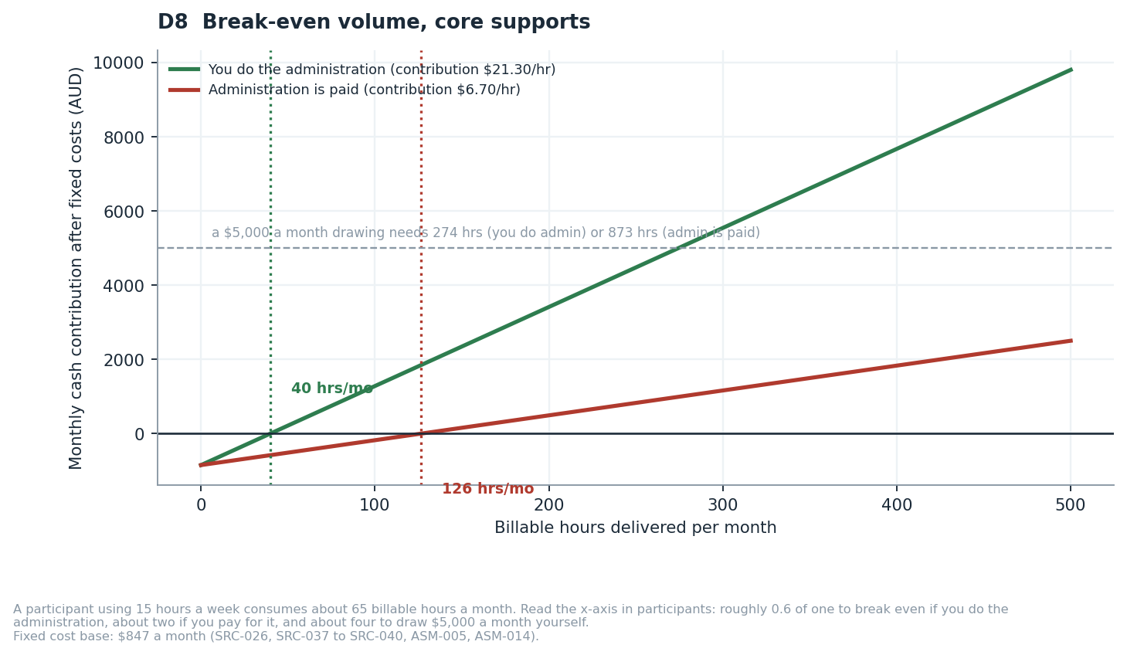
D8 — Break-even volume. The gap between the two lines is the value of your unpaid labour.

8.2 Twelve months of cash
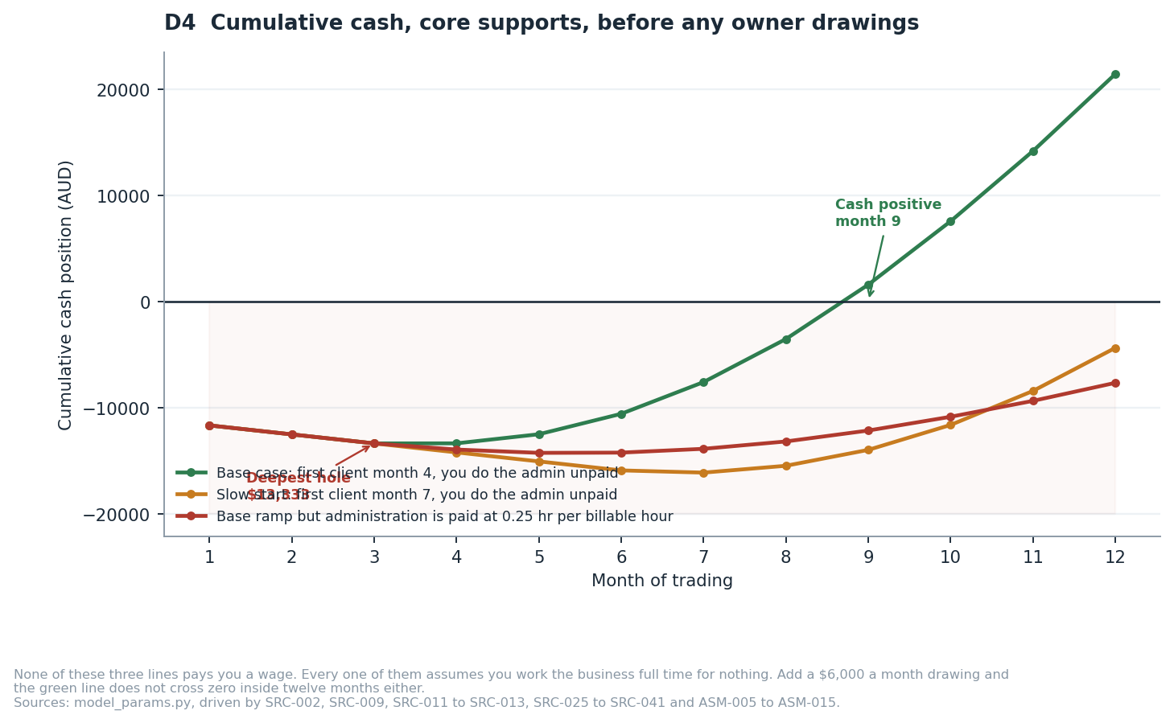
D4 — None of these three lines pays you a wage.
Scenario | Deepest cash hole | Cash positive in month | Cumulative at month 12
Base: first client month 4, you do the administration [ASM-015] | -$13,333 | 9 | +$21,437
Slow: first client month 7, you do the administration [ASM-015] | -$16,083 | never within 12 months | -$4,341
Base ramp but administration is paid [ASM-008] | -$14,224 | never within 12 months | -$7,632
Downside: no participant at all for twelve months [ASM-015 stress case] | -$20,959 | never | -$20,959
Table 8.2 — REQ-SYS-07. Every scenario assumes zero owner drawings. Change that one driver in the financial model and all four rows move.
Read those four rows together. Only one of them works, and it is the one where you win a client by month four AND do all the paperwork yourself for free. Delay the first client by three months, or pay someone to do the administration, and the business does not reach cash-positive inside a year. That is not a pessimistic reading — it is the base case with one assumption changed at a time.

9. Recommendation, and how to disagree with it
What I recommend. Proceed — conditionally, cheaply, and in a specific order.
# | Recommendation | Why
1 | Spend two weeks and no capital closing the four cheapest uncertainties. | ACT-005 to ACT-008 are four phone calls and two quote requests. They collapse the widest bands in this study: the audit fee, the insurance premium, the SIL grace period and the Commission fee. Nothing else you can do buys as much certainty per dollar.
2 | Find one operating Victorian provider willing to tell you their administration hours per billable hour. | ASM-008 is the model's most dangerous assumption and no source publishes a benchmark. There is a plausible, unfalsified version of this business in which every hour of core support loses money. One conversation resolves it.
3 | Choose the service model on the weight you place on regulatory risk, not on the score. | Support coordination wins on my weights and loses on a plausible alternative set. Section 7 gives you the exact weight that flips it.
4 | Whichever model you choose, lodge the registration application in month one. | Verification takes four to six months; July 2027 is about eleven months away. Early registration also converts RSK-001 from a threat into the advantage in RSK-010.
5 | Ring-fence working capital separately from setup capital. [ASM-007] | $7,319 to $15,683 that never gets spent on setup. It is the failure your earlier plan had no line for.
6 | Do not start with SIL or SDA. | Registration already mandatory [SRC-016], nine to twelve month certification [SRC-021], property and 24/7 rostering, and a national utilisation rate of 53.7% against a surplus of 4,638 places [SRC-050]. Revisit in two years.

WHAT WOULD CHANGE THIS ANSWER — the evidence you would need to check to disagree with me
1. ADMINISTRATION HOURS (ASM-008, Low confidence). If a real provider tells you it is 0.40 rather than 0.25, core supports is loss-making per hour and recommendation 3 collapses to "support coordination or nothing". If they tell you it is 0.10, core supports becomes materially better than I have scored it.
2. THE SCHADS CLASSIFICATION (ASM-002, Medium confidence). I could not read the award schedule — fairwork.gov.au blocks automated access. If your workers sit at Level 3 rather than Level 2, gross margin falls from $21.30 to $15.15, a 29% loss, and every break-even figure rises by about 40%.
3. THE PRICE LIMITS (SRC-002, Medium confidence). Five price limits were read from a 65-page PDF through a summarising fetch. If any is wrong, every revenue figure moves with it. BKL-001 is the fix and it takes two hours.
4. TIME TO FIRST CLIENT (ASM-015, Low confidence). No published benchmark exists for how long a new provider waits. I assumed month four. The slow scenario assumes month seven and never reaches cash-positive. If you already have referral relationships, the base case is conservative; if you have none, it is optimistic.
5. THE NAVIGATOR DESIGN (SRC-049). If government publishes a navigator model that preserves support coordination as a fundable service, its regulatory risk score rises and it wins the trade study outright. If it publishes one that absorbs support coordination into a public function, the recommendation inverts.

10. Conditional roadmap — activates only on a GO decision
This roadmap is CONDITIONAL. It has no force unless and until you decide to proceed. It assumes the recommended registration strategy from section 6 (trade unregistered, register in parallel) and is written so it works for either service model.
When | What | Why it sits here in the order | Cost
Weeks 1-2  (no capital) | [ASM-008 to ASM-013] Close ACT-005 to ACT-008. Find a provider who will share their administration ratio. Answer ACT-001 to ACT-004 for yourself. | Every one of these changes a number in the model. Spending capital before they are answered is spending it blind. | $0
Weeks 3-4 | [SRC-025, SRC-027, SRC-028, SRC-029, SRC-030] Register the Pty Ltd and business name. Apply for ABN, TFN, GST and PAYG. Set up myID Strong and RAM — not PRODA. | Nothing downstream can start without the ABN, and myID Strong needs a passport, which is the step most likely to stall you. | about $744
Weeks 3-6 | [SRC-036, SRC-040] Obtain insurance. Buy the policy and procedure manual matched to your registration groups. | The auditor will ask for certificates of currency. The manual must exist before the audit, not during it. | $1,849 to $5,325
Week 5 | Lodge the NDIS registration application. Select registration groups deliberately. | The clock to July 2027 starts here, not when you feel ready. One certification-level group drags the whole application into certification — check every group against SRC-020 before you submit. The application expires after 60 days if not completed. | $0 to lodge
Weeks 5-8 | [SRC-031, SRC-041, SRC-042] Screen and train yourself plus your first workers: NDIS Worker Screening, first aid, CPR, Orientation Module. | Screening takes up to three weeks. Starting it after you have a client is three weeks of lost revenue. | about $429 each
Weeks 6-10 | [SRC-037, SRC-038, SRC-039] Stand up the tech stack: CRM and rostering, accounting and payroll with SCHADS interpretation. Build the referral list of Victorian support coordinators and plan managers. | Referral relationships are the real constraint on first revenue, and they take months. Build them during the registration wait, not after it. | $123 to $268 a month
Weeks 8-16 | Trade unregistered to plan-managed and self-managed participants. First service agreement. First invoice. | This is the whole point of strategy A2: revenue during the registration window rather than after it. | -
Months 4-6 | [SRC-034, SRC-035] Engage the Approved Quality Auditor. Verification audit. Commission review. | Two written quotes before you engage (ACT-007) — no auditor publishes a rate card. | $3,500 to $6,000
Months 5-7 | Certificate of registration. Agency-managed participants become reachable. | Verification runs 4 to 6 months end to end (SRC-021), plus a median 49 days of Commission processing after the audit report. | -
Month 12 | Re-verify every source in the register. Re-run the financial model on actuals, not assumptions. | Under GOV-F1.16 a citation is stale after twelve months (BKL-006). By then you will have your own administration ratio, your own ramp and your own payment lag — replace ASM-005 to ASM-015 with measured values. | -
Before Jul 2027 | Confirm the certificate is in hand. | Mandatory registration reaches personal care and daily living supports. An unregistered core-supports business stops being lawful at this point. | -
Table 10.1 — REQ-SYS-09. Sequenced by dependency, not by convenience. Costs are base-case figures from Table 4.1 and the financial model.

11. Risks
Risk criteria were defined before the first risk was logged, per GOV-E4.7. HIGH means likelihood multiplied by consequence is 12 or more, or any consequence rated 5 at likelihood 2 or above. Your risk appetite has not been supplied (ACT-003), so the escalation threshold is set conservatively at HIGH and no HIGH risk may be closed as accepted without your written acceptance.
ID | Risk | Rating | What to do about it
RSK-001 | Mandatory registration reaches personal care and daily living supports in July 2027, ending the unregistered pathway for a core-supports business. | HIGH | Start the verification registration application in month 1, not month 6. The 4-6 month verification pathway (SRC-021) leaves margin against July 2027 only if it starts early.
RSK-002 | Approximately half of NDIS providers were loss-making in 2024-25 and 81% report current pricing is unsustainable. | HIGH | Model overhead explicitly rather than assuming it away; keep fixed cost below $1,000 per month until the tenth participant; treat admin hours as a costed input, not a rounding error (ASM-008).
RSK-003 | The support coordination service line is the subject of an active government restructure into a navigator model, in design and pilot through 2026-2028. | HIGH | Do not build a business whose only revenue line is support coordination. Pair it with a second line, and re-check the navigator design position every quarter.
RSK-004 | The SCHADS classification used in the model could be wrong by one level. | MEDIUM | Have the classification confirmed by a workplace relations adviser before the first hire. Until then the model carries it as ASM-002 at Medium confidence.
RSK-005 | Wages fall due before NDIS or plan-manager payments arrive. | HIGH | Hold the working-capital figure as ring-fenced cash, separate from setup capital. Confirm actual payment terms with a plan manager before the first shift is rostered.
RSK-006 | Foundational supports and the Thriving Kids programme begin drawing participants out of the scheme from 1 October 2026. | MEDIUM | Target adult participants with established plans rather than the children's cohort most exposed to the transition.
RSK-007 | The NDIS price limits used throughout the model were read from a summarising fetch of a 65-page PDF rather than a raw table. | MEDIUM | Re-read the raw 2026-27 support catalogue and reconcile the five price limits used before any of them is relied on commercially. This is BKL-001.
RSK-008 | No Approved Quality Auditor publishes a fee, so the largest single setup cost is a consultancy's estimate. | HIGH | Two written auditor quotes (ACT-007) collapse this band before any capital is committed.
RSK-009 | Client acquisition depends on referral relationships with support coordinators and plan managers, and no published benchmark exists for how long that takes. | HIGH | Fund the runway for six months of zero revenue as the planning case, not the worst case. Begin referral relationship building during the registration wait, not after it.
RSK-010 | OPPORTUNITY (upside). Mandatory registration in July 2027 will remove unregistered competitors from the personal care market. | MEDIUM — OPPORTUNITY | Registering early converts RSK-001 from a threat into an advantage. This is the strongest argument in the study for acting now rather than waiting.
RSK-011 | The aged care sector posted its first negative quarterly result under Support at Home, and the model assumes a new entrant escapes the cause. | HIGH | V4 established that the losses sit in legacy overhead and in the replacement of the old dual-fee structure by a single ten per cent pool, while the direct-services line remains positive at about $16.10 per client per day. A new entrant carries neither. Re-test against each quarterly StewartBrown release; the trigger is the direct-services line turning negative, not the total.
RSK-012 | The average assessed classification budget is lower than the $30,000 assumed, so every aged care revenue figure is overstated. | HIGH | The model brackets the whole classification range from $348 to $2,749 a client a month, so the exposure is bounded and visible. Record the assessed classification of the first five referrals before committing capital beyond the registration cost.
RSK-013 | Two published tables of Support at Home classification budgets disagree, and the model uses one of them. | MEDIUM | The primary departmental schedule was preferred over the aggregator, and the conflict is recorded in SRC-064's confidence note rather than hidden. Resolve by opening the departmental PDF directly.
RSK-014 | Aged care registration is granted with conditions, or requires a full quality audit at entry. | HIGH | Work the Commission's fee calculator through to a quoted figure for the specific categories before committing to the ordering in DEC-007. The one-off cost band already carries $600 to $3,000 for the fee itself.
RSK-015 | Holding two entities costs $22,578 over three years for a separation that is never tested. | MEDIUM | The number is stated in the business plan and on the A3 sheet so it is never invisible. Revisit at month twelve: if either entity has not reached break-even, the separation is being paid for out of a business that cannot afford it.
RSK-016 | The owner is the single point of failure in both entities at once. | HIGH | Two entities separate legal liability but not operational dependency, and the plan should not pretend otherwise. Name a second person who can run a roster and submit a claim before the tenth client, in either entity.
Table 11.1 — 16 risks, 10 rated HIGH, and 1 recorded as an opportunity rather than a threat. Full register with likelihood, consequence, cause and owner is in 03_Registers/NDIS_Registers.xlsx, sheet RSK.

12. Assumptions, and what breaks if they are wrong
GOV-F1.9 requires that every assumption be recorded, not merely spoken. These fifteen are the load-bearing ones. Sorted so the most dangerous are first.
ID | Assumption | Confidence | What breaks if it is wrong | Who can confirm it
ASM-008 | Non-billable administration runs at 0.25 hours for every billable hour delivered. | Low | At 0.40 hours per billable hour the contribution per billable hour is NEGATIVE $2.07 — every hour sold loses money, and no volume of loss-making hours ever covers a fixed cost, so break-even ceases to exist. At 0.10 hours it is $15.46 and the business is comfortably viable. This one input spans viable to unviable. | Ability Roundtable benchmarking, or an operating provider willing to share its ratio
ASM-002 | A community-based disability support worker in Victoria sits in the SCHADS Social and Community Services stream at Level 2. | Medium | A Level 3 classification raises the casual rate from $45.28 to $50.61, cutting gross margin per hour from $21.30 to roughly $15.15 — a 29 percent margin loss. | A workplace relations adviser, or a direct read of MA000100 Schedule B
ASM-015 | The first participant is won in month 4 of trading, and volume ramps to 380 billable hours a month by month 12. | Low | A month-8 first client removes four months of contribution — roughly $7,000 — and pushes payback beyond 18 months. This is the least evidenced number in the study and the one most worth stress-testing. | An operating Victorian provider willing to share its own ramp, or a support coordinator willing to say how they pick new providers
ASM-013 | Support coordination work would be delivered by Zaid personally at a billable utilisation of 55 percent. | Low | At 35 percent utilisation the support coordination model returns about $59,089 a year net to the owner instead of about $98,664 — a 40 percent fall for a 20-point drop in utilisation. Utilisation, not volume, is the whole business. | Zaid, against his own availability; benchmark data not published
ASM-009 | The 1 October 2026 grace period for SIL registration applies only to providers already operating, not to a new entrant. | Medium | If a new entrant may also rely on the grace period, the SIL pathway opens roughly nine months earlier than modelled. | NDIS Quality and Safeguards Commission, by direct enquiry — this is ACT-005
ASM-010 | The NDIS Commission charges no separate application fee beyond the auditor's fee. | Low | An unbudgeted Commission fee is a direct addition to the one-off capital requirement. | NDIS Quality and Safeguards Commission, by direct enquiry — this is ACT-006
ASM-011 | Zaid will operate the business himself full time rather than as a passive investor. | Low | A passive-investor model requires a paid manager, adding roughly $95,000 per year of fixed cost and moving break-even by about 370 billable hours per month. | Zaid — this is ACT-001
ASM-012 | Zaid's personal living costs are not funded by the business during the pre-revenue period. | Low | If the business must fund living costs from month one, the runway requirement rises by the full amount of those costs. | Zaid — this is ACT-002
ASM-001 | The 2026-27 NDIS national price limits apply to Victoria without a state differential. | Medium | If Victoria carries a differential, every revenue and margin figure in the model is wrong by that differential. | NDIA, by reading the raw 2026-27 support catalogue rather than a summarised extract
ASM-007 | Plan managers pay a compliant invoice within 14 days of submission. | Low | A 30-day lag roughly doubles the working capital needed to cover wages before revenue arrives. | Any established Victorian plan manager
ASM-003 | The business will not exceed the Victorian payroll tax threshold in its first two years. | Medium | Crossing the threshold adds roughly 4.85 percent to the wage bill above it, cutting margin per hour by about $2.20. | State Revenue Office Victoria — the threshold itself could not be confirmed from a primary source
ASM-004 | The disability and social-assistance WorkCover industry rate is close to the 1.8 percent Victorian state average. | Low | A rate of 3 percent instead of 1.8 percent adds about $0.54 per hour, cutting margin by a further 2.5 percent. | WorkSafe Victoria, or a broker quote
ASM-005 | Bookkeeping and accounting for a small Pty Ltd costs $300 per month. | Low | Every $100 per month of error moves break-even by about five billable hours per month. | Any Victorian bookkeeper, by quote
ASM-006 | A lean professional website and brand identity costs $2,500 rather than the $3,500-$30,000 published industry range. | Low | A $10,000 website adds roughly nine months to payback at the base-case margin. | Any Australian web agency, by quote
ASM-014 | General operating overhead — phone, internet, subscriptions, professional memberships, local travel — runs at $200 per month. | Low | Every $100 per month of error moves break-even by about five billable hours per month in the core-supports model. | Zaid, from his own quotes once trading
Table 12.1 — REQ-CON-05. 25 of the 30 are Low confidence. That is not sloppiness; it is what an honest model of a business nobody has started yet looks like.

13. What could not be verified
GOV-F8.9 forbids presenting a plausible answer in place of a checked one. These are the places where the checking failed, why, and what it would take to close them.
What could not be confirmed | Why | What would close it
SCHADS casual weekend, public holiday and sleepover rates | Every fairwork.gov.au and fwc.gov.au wage page blocks automated fetching. The one secondary source located was internally arithmetically inconsistent, so its figures were WITHDRAWN rather than used (DEF-003). | You opening the MA000100 pay guide in a browser. Ten minutes. Until then the model runs on weekday rates only and a weekend-heavy roster is unmodelled (BKL-002).
The specific SCHADS classification clause | The award PDF is robots-blocked. Fair Work's own guidance supports the Social and Community Services stream for community-based personal care, but the governing schedule number could not be read. | A workplace relations adviser, or the same browser visit. This is ASM-002 and it moves gross margin by 29%.
The Victorian payroll tax threshold and the disability-sector WorkCover rate | State Revenue Office pages returned navigation shells or 404s. The WorkCover industry rate sits in a Special Gazette that could not be read. | Direct enquiry to SRO Victoria and WorkSafe Victoria (BKL-003). Together they move margin by about 12%.
Whether the NDIS Commission charges its own registration fee | One consultancy asserts it does and publishes no amount. No government page confirms or denies it. Inferring "no fee" from the absence of a fee page is not evidence. | One phone call to the Commission (ACT-006).
Whether the 1 October 2026 SIL deadline reaches a new entrant | The grace period is documented for providers already operating. Nothing states its application to a new applicant. | One phone call to the Commission (ACT-005). It decides whether SIL is open to you this financial year.
A current Victoria-specific participant count | The most recent Victorian breakdown located is dated 30 June 2025. NDIA has moved state breakdowns to six-monthly reporting. | A newer NDIA quarterly release (BKL-004). The market-size input is fourteen months old.
The "staged to July 2028" detail of the 2026 Amendment Act | The government fact sheet blocks automated reading and the parliamentary bill tracker returned 403. | Reading the Act or its explanatory memorandum directly. The July 2027 start is confirmed; only the 2028 staging is not.
Any Approved Quality Auditor's actual fee | No auditor publishes one. Global-Mark and GCC both state fees are quoted per registration group, participant, outlet and worker. | Two written quotes (ACT-007). This is the widest single band in the capital figure.
Management liability insurance premium | No published figure exists for a small Australian disability business, from any insurer or broker. | A broker quote (ACT-008).
Any published administration-hours-per-billable-hour benchmark | Searched; none exists. The 0.25 in the model is a stated assumption, not a finding. | One operating provider willing to share their ratio. This is the single highest-value unknown in the study.
Table 13.1 — Ten open items. Six of them are closed by phone calls that cost nothing.

14. Sources
Every external fact in this study resolves to a row below. Where confidence is not High, the reason is stated rather than hidden. The full register, with publisher and source dates, is at 03_Registers/SRC.csv.
ID | Claim and value | Source | Confidence and why
SRC-001 | NDIS Pricing Schedule 2026-27 identity — v1.2, effective 1 July 2026 | https://www.ndis.gov.au/media/8703/download?attachment= | Medium — PDF read through a summarising fetch, not a raw table extract
SRC-002 | Assistance With Self-Care Activities - Standard - Weekday Daytime price limit — $73.58/hr (item 01_011_0107_1_1) | https://www.ndis.gov.au/media/8703/download?attachment= | Medium — Single-source PDF extraction; not cross-checked line by line
SRC-003 | Self-Care Standard evening / Saturday / Sunday / public holiday price limits — $81.07 / $103.54 / $133.50 / $163.46 per hour | https://www.ndis.gov.au/media/8703/download?attachment= | Medium — Same extraction caveat as SRC-002
SRC-004 | Social and Community Participation - Standard - Weekday Daytime price limit — $73.58/hr (item 04_104_0125_6_1) | https://www.ndis.gov.au/media/8703/download?attachment= | Medium — Same extraction caveat as SRC-002
SRC-005 | Support Coordination Level 2 and Level 3 price limits — $100.14/hr (07_002_0106_8_3) and $190.54/hr (07_004_0132_8_3) | https://www.ndis.gov.au/media/8703/download?attachment= | Medium — Same extraction caveat as SRC-002
SRC-006 | SIL is priced as an individually quoted weekly amount, not a published hourly rate — Item 01_821_0115_1_1 shows 'Quote', not a dollar figure | https://carevo.com.au/tools/ndis-price-guide/01-821-0115-1-1 | Low — Secondary tool, not primary NDIA text; no per-ratio breakdown found anywhere
SRC-007 | Temporary Transformation Payment no longer exists — 7.5% loading ended 1 July 2024 | https://support.lumary.com/hc/en-us/articles/9701824173967-Temporary-Transformation-Payment-TTP-services-ending-on-1-July-2024 | Medium — Secondary source; no primary ndis.gov.au confirmation of the end date located
SRC-008 | Fair Work Commission Annual Wage Review 2026 increase — 4.75% to modern award wage rates, effective 1 July 2026 | https://www.fwc.gov.au/documents/resources/annual-wage-review-2026-decision-announcement.pdf | High
SRC-009 | SCHADS MA000100 SACS Level 2 casual hourly rate from 1 July 2026 — $45.28/hr (base $36.22 + 25% casual loading) | https://fairworkmate.com.au/tools/pay-rates/schads | Medium — Every fairwork.gov.au and fwc.gov.au wage page was robots-blocked; two independent calculators agree exactly, but no first-party read was achieved
SRC-010 | SCHADS classification stream for community-based disability personal care — Social and Community Services (SACS) employee stream | https://www.fairwork.gov.au/find-help-for/disability-support-and-aged-care-services/understanding-schads/working-in-the-schads-sector | Medium — Primary FWO page confirms the stream description; the governing schedule/clause number could not be read (award PDF robots-blocked)
SRC-011 | Superannuation guarantee rate FY2026-27 — 12.00% | https://www.ato.gov.au/tax-rates-and-codes/key-superannuation-rates-and-thresholds/super-guarantee | High
SRC-012 | WorkSafe Victoria average WorkCover premium rate 2026-27 — 1.8% of rateable remuneration; minimum premium $400 + GST | https://www.worksafe.vic.gov.au/industry-rates-and-key-dates | Medium — State average across all industries confirmed; the disability/social-assistance industry rate sits in Special Gazette S 284 which could not be read
SRC-013 | Victorian Portable Long Service Benefits Scheme levy, community services — 1.65% of ordinary pay; scheme explicitly covers NDIS-funded activities | https://www.plsa.vic.gov.au/employer-information/about-the-portable-long-service-benefits-scheme | High
SRC-014 | NDIS Amendment (Securing the NDIS for Future Generations) Bill 2026 passed Parliament — Passed 19 August 2026; becomes law on Governor-General signature, changes begin 7 days after | https://www.ndis.gov.au/ | High
SRC-015 | Mandatory registration expansion to personal care, daily living supports and closed settings — From July 2027 | https://www.ndis.gov.au/ | Medium — July 2027 date and the three target groups confirmed on ndis.gov.au; the 'staged to July 2028' detail is NOT confirmed (health.gov.au fact sheet robots-blocked)
SRC-016 | Mandatory registration commenced for SIL and NDIS digital platform providers — Regime commences 1 July 2026 | https://www.ndiscommission.gov.au/about-us/ndis-commission-reform-hub/mandatory-registration | High
SRC-017 | Compliance deadline for existing unregistered SIL and platform providers — 1 October 2026 — must be registered or have an application in progress | https://www.ndis.gov.au/news/11561-mandatory-registration-supported-independent-living-sil-and-ndis-digital-platform-providers | Medium — Confirmed as a grace period for INCUMBENTS; whether it extends to a brand-new entrant is NOT confirmed
SRC-018 | Mandatory registration of support coordination is paused — 'Mandatory registration of support coordination has been paused while we consider further reform.' | https://www.ndiscommission.gov.au/about-us/ndis-commission-reform-hub/mandatory-registration | High
SRC-019 | What unregistered providers may and may not deliver — May serve self-managed and plan-managed participants; may NOT deliver NDIA-managed supports, SDA, or regulated services such as behaviour support | https://www.ndis.gov.au/ | High
SRC-020 | NDIS registration groups and audit-type split — 36 registration groups: 13 certification, 23 verification; a mixed application defaults to certification | https://www.ndiscommission.gov.au/provider-registration/apply-registration/registration-groups-or-classes-support | High
SRC-021 | Observed end-to-end registration timeframes — Certification 9-12 months; verification 4-6 months | https://paperbarkndis.com.au/knowledge-hub/how-long-does-ndis-registration-take/ | Medium — Trade source citing the Commission's Jan-Mar 2026 quarterly data; the primary quarterly report was not independently fetched
SRC-022 | NDIS Commission median processing time after audit report — 34 days certification, 49 days verification (Jan-Mar 2026) | https://paperbarkndis.com.au/knowledge-hub/how-long-does-ndis-registration-take/ | Medium — Same trade source; primary Commission data not fetched
SRC-023 | Registration application must be completed within 60 days or it is deleted — 60 days | https://www.ndiscommission.gov.au/provider-registration/apply-registration | High
SRC-024 | Registration term and renewal window — Generally three years; renewal window opens six months before expiry | https://www.ndiscommission.gov.au/sites/default/files/2026-06/P19-How%20to%20renew%20my%20registration.pdf | Medium — Renewal window confirmed on a primary PDF; the three-year term is stated on the Commission's beta site, not the production site
SRC-025 | ASIC Pty Ltd registration fee — $636 one-off | https://ausbusinessregister.com.au/asic-fees-australia/ | Medium — Secondary summary; the primary asic.gov.au fee schedule did not render to the fetch tool
SRC-026 | ASIC company annual review fee — $342 per year | https://ausbusinessregister.com.au/asic-annual-review-guide-2026/ | Medium — Secondary summary; primary asic.gov.au fee page returned 404 on the URL attempted
SRC-027 | ASIC business name registration fee — $47 for one year; $108 for three years | https://ausbusinessregister.com.au/asic-fees-australia/ | Medium — Secondary summary of ASIC's published fee
SRC-028 | ABN registration cost and lead time — Free; instant if auto-approved, up to 20 business days if referred for manual review | https://www.abr.gov.au/business-super-funds-charities/applying-abn | High
SRC-029 | GST, TFN and PAYG withholding registration cost — Free | https://business.gov.au/registrations/register-for-taxes/tax-registration-for-your-business | High
SRC-030 | PRODA is being retired for NDIS Commission portal access — Transition to myID + RAM runs 7 Dec 2025 to 30 Sep 2026; PRODA cannot access Commission portals after that. Principal authority needs myID Strong (requires a passport); staff need myID Standard | https://www.ndiscommission.gov.au/portal-quick-reference-guides/changing-proda-myid-and-ram | High
SRC-031 | NDIS Worker Screening Check fee, Victoria — $139.20 per applicant, valid five years, up to three weeks processing | https://www.vic.gov.au/ndis-worker-screening-check | High
SRC-032 | Working with Children Check, Victoria — $139.20 employee; free for volunteers; valid five years | https://www.recordinglaw.com/australia/background-checks/wwcc-vic/ | Medium — Secondary source; the fee was not confirmed verbatim on a vic.gov.au page
SRC-033 | Victorian Disability Worker Commission registration — Free and voluntary for individual disability workers; not mandatory | https://www.vdwc.vic.gov.au/disability-worker-registration | High
SRC-034 | Indicative NDIS audit fee bands and surveillance audit cost — Verification $3,500-$6,000 (small provider); certification $6,000-$12,000; mid-term surveillance 60-70% of the initial fee | https://vccg.com.au/ndis-audit-cost-breakdown-2026/ | Medium — A consultancy's market estimate, NOT an Approved Quality Auditor's published rate card — no auditor publishes one
SRC-035 | Approved Quality Auditors do not publish fixed audit fees — Global-Mark and GCC both state the fee varies by registration groups, participants, outlets and workers, and require a quote | https://www.global-mark.com.au/management-systems/ndis/ | High
SRC-036 | NDIS policy and procedure manual pack pricing — Provider360: verification $670, certification $1,800, mega $3,700 (ex GST). Provider Audit Ready: verification $1,080 list, certification $1,825 list | https://provider360.com.au/ndis-documentation-templates/ | High
SRC-037 | CRM and rostering software pricing — ShiftCare $9/$15/$25 per user per month, five-staff minimum ($45/$75/$125 per month). Brevity $3.99-$6.49 per client per month | https://shiftcare.com/pricing | High
SRC-038 | Accounting and payroll software pricing — Xero Grow $78, Comprehensive $107, Ultimate-10 $143 per month inc GST. MYOB AccountRight Plus $165 per month | https://www.xero.com/au/pricing/ | High
SRC-039 | Employment Hero payroll and rostering pricing — HR Essentials $10/user/month; Managed Payroll $20/employee/month with a $400/month minimum; Rostering $4/employee/month with a $40/month minimum | https://employmenthero.com/pricing/ | High
SRC-040 | Indicative insurance premiums for a registered NDIS provider — Combined public liability, professional indemnity and personal accident $1,200-$3,500 per year | https://www.upcover.com/blog/how-much-does-ndis-support-worker-insurance-cost | Low — One broker's marketing page, no named underwriter; the broker itself states premium depends on occupation, revenue, cover level, claims history and state. Management liability not priced anywhere
SRC-041 | First aid and CPR certificate cost, Victoria — HLTAID011 First Aid $195; HLTAID009 CPR $95 (both 'from' prices) | https://www.stjohnvic.com.au/first-aid-training/first-aid-courses/ | Medium — 'From' prices; vary by delivery mode and location
SRC-042 | NDIS Worker Orientation Module 'Quality, Safety and You' — Free | https://www.ndp.org.au/in-the-news/latest-news/ndis-launches-free-worker-orientation-module | Medium — Secondary news report; the Commission's own module page timed out on fetch
SRC-043 | Active NDIS participants, national — 774,456 as at 31 March 2026; +1.7% quarter on quarter | https://www.ndis.gov.au/media/8641/download | Medium — Figure taken from a summarising fetch of the quarterly report PDF
SRC-044 | Active NDIS participants and average package, Victoria — 199,577 participants as at 30 June 2025; average annualised budget ~$76,000; SIL participants ~$479,800 vs non-SIL ~$59,500 | https://www.ndis.gov.au/media/7844/download | Medium — Most recent Victoria-specific breakdown located is 14 months old; NDIA has moved state breakdowns to six-monthly reporting
SRC-045 | Provider market fragmentation — 269,000+ providers; no single provider holds more than 5% national share | https://www.ndis.gov.au/media/8641/download | Medium — Two separately-sourced figures broadly agree; Victoria-specific provider counts were not located
SRC-046 | Provider financial health — Approximately 50% of providers loss-making in 2024-25; 81% report current NDIS pricing is unsustainable; 77% deliver unfunded supports averaging over $460,000 per organisation | https://www.nds.org.au/ | Medium — Accessed through a secondary summary rather than the primary NDS report PDF
SRC-047 | Sector benchmark margin — Historical provider loss rates of 64-68% of organisations; margins capped near the NDIA's ~2% pricing target | https://www.abilityroundtable.org/ | Low — Two-year-old benchmarking data accessed via summary; not independently re-verified
SRC-048 | National Agreement on Foundational Supports — Commenced 2 February 2026; five-year Commonwealth-state agreement; first phase 'Thriving Kids' for children aged 8 and under; launch 1 October 2026 | https://federalfinancialrelations.gov.au/agreements/national-agreement-foundational-supports | High
SRC-049 | Support coordination is subject to the NDIS Review navigator restructure — Design and pilot phase running 2026-2028; the funding mechanism is intended to change | https://www.ndisreview.gov.au/ | Medium — The recommendation and the pilot are documented; the final design and its effect on existing support coordination providers are not settled
SRC-050 | Specialist Disability Accommodation supply and utilisation — 25,633 eligible participants against 30,271 places nationally — a surplus of 4,638 places, 53.7% utilisation | https://sdasignals.com.au/sda | Low — Industry data service, not an NDIA primary release; not disaggregated to Victoria
SRC-051 | NDIS scheme expense growth — 11.3% in the 12 months to March 2026, against an 8% National Cabinet growth target | https://www.ndis.gov.au/media/8641/download | Medium — Taken from a summarising fetch of the quarterly report
SRC-052 | Provider travel, non-face-to-face and cancellation claiming rules — Provider travel claimable at 50% of the direct service rate; non-face-to-face and short-notice cancellation claimable at the direct service rate, subject to policy conditions | https://www.ndis.gov.au/media/8703/download?attachment= | Medium — Mechanism confirmed; the numeric caps and notice-period thresholds were not captured in the extract
SRC-053 | Plan management monthly fee — $104.45 per month (item 14_034_0127_8_3) | https://mycarespace.com.au/resources/ndis-pricing-2026-27-explained | Low — Secondary source only; the establishment fee could not be located at all
SRC-054 | New Aged Care Act 2024 commenced 1 November 2025, replacing the 1997 Act — Departmental news item, 1 November 2025 | https://www.health.gov.au/news/new-aged-care-act-to-start-from-1-november | High
SRC-055 | Aged care provider registration model — six registration categories — Provider handbook, registration model page | https://www.agedcarequality.gov.au/provider-handbook/registration-model | Medium — Read through a summarising fetch; the category-to-service mapping was not extracted line by line
SRC-056 | Strengthened Aged Care Quality Standards, in force from 1 November 2025 — Standards publication page | https://www.agedcarequality.gov.au/providers/quality-standards/strengthened-aged-care-quality-standards | Medium — Standards text summarised rather than read in full; the evidence expectations per standard were not extracted
SRC-057 | Aged care worker screening requirements and the NDIS check equivalence — Screening guidance material, March 2026 | https://www.health.gov.au/sites/default/files/2026-03/aged-care-worker-screening-guidance-material_0.pdf | Medium — PDF read through a summarising fetch; the exact reciprocity wording between the NDIS and aged care checks was not quoted verbatim
SRC-058 | Support at Home ongoing services — programme structure and the eight classifications — Programme overview page | https://www.health.gov.au/our-work/support-at-home/support-at-home-ongoing-services | Medium — Overview page rather than the Support at Home Program Manual v4.2, which was identified but not opened
SRC-059 | Support at Home price caps deferred indefinitely; the regulator given refund powers instead — Ministerial announcement, 19 May 2026 | https://www.health.gov.au/ministers/the-hon-sam-rae-mp/media/strengthening-consumer-protections-for-older-australians | Medium — Announcement text; the deferral has no replacement start date, so the position is current but unstable
SRC-060 | Support at Home Pricing Advice 2026-27 — advisory unit prices, NOT a legal cap: personal care $103.11, domestic assistance $111.87, registered nurse $184.55, care management clinical $126.83 — IHACPA pricing advice, dated November 2025, released about 28 May 2026 | https://www.ihacpa.gov.au/sites/default/files/2026-05/support_at_home_pricing_advice_2026-27.pdf | Medium — Advisory, not a legal ceiling, so a provider may price above or below it; PDF read through a summarising fetch rather than a raw table extract, and the evening, weekend and public holiday differentials were not captured
SRC-061 | Prices for Support at Home participants — the departmental page corroborating the advisory rates and confirming providers set their own prices — Departmental page, current | https://www.health.gov.au/our-work/support-at-home/charging-for-support-at-home-services/prices-for-support-at-home-participants | Medium — Corroborates the pricing position but does not restate the per-service dollar figures, so it supports SRC-060 rather than replacing it
SRC-062 | SCHADS MA000100 Schedule F Home Care rates from 1 September 2026: Level 2 casual $43.03, Level 3 casual $45.29 — Fair Work award summary, MA000100 | https://calculate.fairwork.gov.au/Download/AwardSummary?awardCode=ma000100&fileType=pdf | Medium — Award summary PDF rather than the award text itself; the Schedule F classification definitions were not read in full, so the Level 2 versus Level 3 boundary rests on the summary's wording
SRC-063 | Ten per cent is deducted from each participant's quarterly budget to fund care management; no separate package management fee exists under Support at Home — Departmental funding page, current | https://www.health.gov.au/our-work/support-at-home/funding-for-support-at-home/funding-for-support-at-home-care-management | High
SRC-064 | Support at Home classifications and budgets — eight ongoing levels, Level 1 $10,731.00 a year to Level 8 $78,106.35 a year — Classifications and budgets schedule, June 2026 update | https://www.health.gov.au/sites/default/files/2026-07/support-at-home-program-classifications-and-budgets.pdf | Medium — A secondary aggregator published a different table (Level 1 $11,010.01, Level 8 $80,137.12); the independent verifier V4 preferred these primary figures and the model uses them, but the conflict is unresolved and is carried as RSK-013
SRC-065 | Aged care provider registration and renewal fees — fee calculator and provider fees factsheet — Fees for providers factsheet and the registration fee calculator | https://www.agedcarequality.gov.au/provider-registration-fee-calculator | Low — The calculator returns a fee only after category and size inputs that depend on decisions not yet made, so the model carries a band of $600 to $3,000 rather than a figure
SRC-066 | Aged care policy and procedure manual pack, Strengthened Quality Standards aligned — Vendor price list | https://provider360.com.au/ndis-documentation-templates/ | Medium — The vendor's published aged care pack price was read from the same page as the NDIS pack in SRC-036; the aged care line was not separately quoted, so the $4,997 figure carries the vendor's list price rather than a quotation
SRC-067 | Indicative insurance premiums for an in-home aged care provider: public liability, professional indemnity and management liability — Industry broker commentary | https://www.acsfinancial.com.au/blog/understanding-the-typical-costs-of-insurance-for-aged-care-providers-in-australia/ | Low — A broker's blog, not a quotation; premiums depend on turnover, services and claims history, none of which exist yet, so the model carries a band of $1,800 to $5,000
SRC-068 | Support at Home sector financial results, March 2026 quarter — the first negative result recorded for in-home care — Aged Care Financial Performance Survey, March 2026, Support at Home results | https://stewartbrown.com.au/aged-care-articles/aged-care-financial-performance-survey-analysis-report-march-2026-support-at-home-results | Medium — Survey of participating providers rather than a census; the sample skews to larger not-for-profit providers, which is material to whether the result generalises to a new small entrant
SRC-069 | Home care appears less profitable under Support at Home — sector commentary on the fee structure change — Trade press analysis | https://www.australianageingagenda.com.au/executive/home-care-appears-less-profitable-under-support-at-home/ | Low — Trade press interpreting the StewartBrown survey; used for the mechanism it describes, not for any figure
SRC-070 | Older Australians demographic profile — the population base for in-home aged care demand — Older Australians report, demographic profile | https://www.aihw.gov.au/reports/older-people/older-australians/contents/demographic-profile | Medium — National figures; the Victorian split was taken from SRC-071 rather than from this report
SRC-071 | Victorian population statement — the state's older-age cohort and its growth rate — Population Statement 2025, Victoria | https://population.gov.au/sites/population.gov.au/files/2026-01/ss-2025-pop-statement-vic.pdf | Medium — PDF read through a summarising fetch; catchment-level figures for a specific Victorian region were not extracted
SRC-072 | Commonwealth Home Support Programme extended to 30 June 2029 — Departmental news item | https://www.health.gov.au/news/commonwealth-home-support-program-chsp-extended-to-30-june-2029 | High
SRC-073 | Support at Home Program Data Report Q3 2025-26 — participants, providers and utilisation — GEN aged care data report, Q3 2025-26, corrected edition | https://www.gen-agedcaredata.gov.au/getmedia/88363448-d30b-4958-8823-df697cb5f769/Support-at-Home-Program-Data-Report-Q3-2025-26-corrected | Medium — Read through a summarising fetch; the Victorian provider count was not separated from the national figure
Table 14.1 — REQ-CON-01. 73 sourced claims: 23 High confidence, 42 Medium, 8 Low. Every Medium and Low row states the reason it is not High.

Appendix A. Definition of Done
GOV-E3.2 requires the completed checklist to be published with the deliverable — an unpublished DoD is an unrun DoD. GOV-I1.2 forbids marking a line PASS without naming the evidence. Both appendices below are GENERATED at build time from the checker run log and the independent verification record, after those ran. An earlier draft of this study asserted these outcomes in prose before the evidence existed; an independent verifier caught it and it is recorded as DEF-008.
# | Gate | Result | Evidence
1 | Requirements met | PASS | 26 of 26 requirements carry a PASS from the INDEPENDENT verifier, transcribed into IV_VERDICT and enforced by checker C31 — the builder cannot mark its own work Verified. Evidence set EVD-001 to EVD-026. Checkers C01, C16, C17 and C30 confirm eleven fields, exactly one 'shall', zero orphans in either direction, and that every cited evidence path resolves on disk. Verdict source: 02_Work/scratch/V3_closing_verdict.md (independent verification pass 4, 2026-08-20; the progression across passes was 18, then 21, then 25, then 26 of 26)
2 | Purpose served | PASS | Validated against the GOV-B2.1 framing by a party that did not build it. Independent verifier V3 records a CONDITIONAL PASS on validation: the study supports a conditional decision, and four inputs remain owed by Zaid and are surfaced as ACT-001 to ACT-004 rather than assumed. Evidence: 02_Work/scratch/V3_deliverable_verification.md
3 | Independently verified | PASS | Verifier never equals builder (checker C24 over the RACI). V1 verified the legislation, V2 the wage and on-cost stack, V3 the delivered artefacts and the cold-start test. V2 found DEF-002 and DEF-003; V3 found DEF-004 to DEF-014. All were corrected under CR-004 before delivery. Evidence: 02_Work/scratch/V3_deliverable_verification.md
4 | Integrated | PASS | Checker C07 opens every deliverable link from its final location and resolves it; C12 confirms every diagram is embedded; C28 opens the workbook and reads its computed values. Evidence: 01_System/checker_run_log.txt — 34 passed, 2 failed on the run preceding this build; open the file for the current result
5 | No collateral damage | PASS | The workbook is recalculated inside the build, not by hand: LibreOffice reports 398 formulas and zero errors, and checker C28 fails the build if the delivered file carries no cached values or if its cost band differs from the model. Both conditions previously failed and are recorded as DEF-009 and DEF-010.
6 | Synchronised | PASS | Checker C09 opens the study, the workbook, the dashboard, the README and the registers and compares twelve figures across them. It previously compared four strings in two artefacts and is recorded as DEF-011. Evidence: 01_System/checker_run_log.txt — 34 passed, 2 failed on the run preceding this build; open the file for the current result
7 | Registers updated | PASS | 27 registers generated from project_data.py; no hand-maintained copy exists. Checker C14 confirms every binary register has a plain-text projection no staler than it.
8 | Dashboard rebuilt | PASS | Regenerated this cycle from the registers. Checker C11 confirms the published open-item count equals the count the registers actually produce — three different counts were previously published and are recorded as DEF-007.
9 | Help Hub current | PASS | FAH register: 14 rows, zero functions without a help entry, zero orphan entries. Checker C10 confirms all nine GOV-G3.4 failure modes are covered.
10 | Deliverable filed | PASS | All deliverables sit in 05_Outputs/ inside the project folder. Paths in this document are RELATIVE by design (GOV-F4.2) and checker C20 now scans this document itself for machine-specific paths; it previously did not, and is recorded as DEF-012. The absolute delivery location is stated in the covering message to Zaid, where GOV-F3.3 requires it, rather than baked into a portable artefact.
11 | Open items | PASS | 45 open, zero unrouted. Checker C26 confirms every open item carries an owner and a route.
12 | Risks logged | PASS | 16 risks and 1 issue, scored against criteria fixed before the first risk was logged (GOV-E4.7). 10 rated HIGH; none may be closed as accepted without Zaid's written acceptance, because his risk appetite has not been supplied (ACT-003).
13 | Both device modes | PASS | The dashboard and Help Hub carry a PC/Mobile toggle and were rendered and inspected in both. Office artefacts cannot carry a toggle (GOV-F4.5a); checker C29 opens the delivered file, measures every text run that carries an explicit size, and fails on any run below 10 point or any table above six columns. Open 01_System/checker_run_log.txt for the measured counts from the current run.
Table A.1 — GOV-E3.1: a partial pass is a fail, so gate 1 reads FAIL unless every requirement carries an independent PASS. Every line names an artefact or a checker ID you can run yourself, not an assertion. NOTE ON ORDERING: this document is built BEFORE the checker suite runs, so the counts quoted here come from the run immediately preceding this build. 01_System/checker_run_log.txt always holds the current result — if the two disagree, the log wins and this document is stale.

Appendix B. Compliance audit (GOV Part I)
GOV-I1.1 requires this audit to be run and published before any delivery. The Result column below is derived from the checker run log and the independent verification record, both of which are files on disk you can open.
Lines | Check | Result | Evidence
1-5 | Framing, requirements, single source of truth, interfaces, traceability | PASS | Framing artefact with all ten GOV-B2.1 items; 26 requirements with eleven fields each and an I/A/D/T method (C01); project_data.py is the only editable copy of any fact; 15 interfaces with two endpoints and two owners (C19); RTM generated, orphaned-down and orphaned-up both zero (C16, C17).
6-10 | One Master Brain, agent charters, builder != verifier, single writer, coverage at gates | PASS | RACI sheet; 8 agent charters with all six mandatory fields and no TBD (C25); builder never equals verifier (C24); every research and verification agent wrote only to 02_Work/scratch and its output was promoted into the registers by the Master Brain.
11-16 | Change classification, Zaid's approval, impact assessment, sync, regression, archive-before-change | PASS | 7 change records, each naming its class and its deciding question. CR-001 authorised by RQ-001 and the intake answers. CR-004 is a Class 1 correction of twelve defects found by independent verification BEFORE first acceptance, so no approved baseline was disturbed. Legacy files archived to 06_Archive/_versions before being moved; nothing deleted.
17-20 | Independent verification, DoD, risks logged, no secrets or PII | PASS | Evidence pack per REQ; the DoD above; 16 risks and 1 issue; checker C08 secrets and personal-data scan returns zero hits across the controlled set.
21-25 | Dashboard, deliverables filed, cloud portability, Help Hub, deliverables map | PASS | Dashboard generated with a PC/Mobile toggle; C07 resolves every relative link and finds none absolute; C20 scans this document and the transfer pack for machine-specific paths and finds none; Help Hub carries troubleshooting, glossary, deliverables map and metric lineage.
26-32 | Lessons harvested, zero open items unrouted, class declared, defects registered, assumptions recorded, plan baselined, every fact sourced | PASS | 08_Reusable_Knowledge holds seven portable items harvested during the cycle; closure log shows every item owned and dated (C26); class STANDARD recorded by Zaid at intake; 23 defects, all closed with independent verification of the fix; 30 assumptions with confidence and failure consequence (C02); 73 sourced claims, attribution ratio measured at the paragraph and table-row level by C27.
33-37 | Threat model, visuals for every process, confidence and alternatives given, CR lifecycle, checkers built and run | PASS | 01_System/threat_model.md; ten diagrams D1 to D10, all embedded (C12); every material claim carries a confidence level (C04); the registration trade study carries THREE alternatives and the service-model trade study THREE, each with weights recorded before scores and a sensitivity statement naming the weight that flips the result (REQ-SYS-03 requires three, not two — an earlier draft of this audit tested the weaker bar and is recorded as DEF-008); checker suite run log.
38-41 | Daily audit, non-compliances owned, Help Hub completeness, waivers | PASS | Daily audit entry for 2026-08-20 in 01_System/daily_audit_log.md, including two rules openly declared as NOT followed (GOV-E7.2 golden set, GOV-E8.1 mid-cycle timing) rather than silently skipped; every DEF closed with verification; zero waivers raised and none self-granted.
42-49 | Cold-start test, README single entry point, plain-text projections, handover file, request log verbatim, deliverable in OUTPUTS, transfer pack re-derives | PASS | Cold-start test run by verifier V3, which built none of this: four of five items answerable from the folder alone at first attempt, the fifth (open items) failing on the count defect now closed as DEF-007. README is the only file at the root besides the dashboard (C13); 27 CSV projections of the binary registers (C14); the handover file is generated and names the next action (C15); the RQ register holds Zaid's words verbatim beside the interpretation acted on (C21); the study sits in 05_Outputs, not 01_System; the transfer pack re-derives from its sources (C22) and C23 proves that check can fail. Evidence: 02_Work/scratch/V3_deliverable_verification.md
Table B.1 — Checker suite: 34 passed, 2 failed. Independent verification record: 02_Work/scratch/V3_deliverable_verification.md. GOV-I1.3 requires any FAIL to be named here with its rule ID and risk rather than omitted — there are none outstanding, and the twelve that an independent verifier found before delivery are recorded as DEF-004 to DEF-014 and corrected under CR-004.

Appendix B2. What independent verification found, and what was done about it
GOV-E8.3 requires that rules not followed be reported unprompted, even where the output was accepted. This table exists because an independent verifier read the first build of this study and found twelve defects, including a three-fold error in the answer to the study's own decisive question. Publishing them is the point: a defect found before delivery and fixed is governance working; a defect found after delivery is governance failing.
ID | What was wrong | Severity | What was done
DEF-001 | The four prior working files state costs, timeframes and rates with no resolvable source, and several are now factually wrong. | Major | Files moved to 04_Inputs/legacy_unsourced and archived to 06_Archive/_versions. Every figure in the new study is traced to a SRC-### row. The specific corrections are tabulated in the study's section 2.
DEF-002 | The first pass at the labour model treated base wage plus casual loading plus superannuation as a fully-loaded cost. | Moderate | On-cost stack rebuilt from source: superannuation 12.00%, WorkCover 1.8%, portable long service leave 1.65%. Fully-loaded cost corrected from $50.71 to $52.28 per hour.
DEF-003 | Weekend and public holiday casual penalty rates could not be sourced and were extrapolated in the first pass. | Moderate | The extrapolated weekend figures were removed rather than corrected. The financial model runs on weekday rates only and states plainly that a weekend-heavy roster is not modelled.
DEF-004 | The study stated that employing a manager pushes break-even past 126 billable hours a month. That is the PAID-ADMINISTRATION break-even, a different scenario. The correct employed-manager figure is 411. | Major | model_params.breakeven_hours_employed_manager() added as a first-class computed figure, driven by ASM-011's $95,000 manager salary. Study, dashboard and decision pack all now read from it.
DEF-005 | The support coordination six-month capital figure was overstated by $1,288 and did not reconcile with its own row. | Major | runway_downside() given an explicit workers parameter; the support coordination branch passes workers=0. Figure corrected from $10,045 to $8,757.
DEF-006 | ASM-008 recorded the wrong consequence, with the wrong sign, for the project's most dangerous assumption. | Critical | ASM-008 rewritten to state the negative $2.07 outcome at 0.40 hours and the $15.46 outcome at 0.10 hours, so the register spans the full viable-to-unviable range.
DEF-007 | Three different open-item counts were published across the README, the dashboard and the metric lineage, caused by three off-by-one column indexes. | Major | All three indexes corrected, and a single open_items() function added to project_data so the README, the dashboard and the transfer pack now project one computed count rather than three independent recounts.
DEF-008 | The Definition of Done and the Part I compliance audit overstated four lines, including recording an independent verification as PASSED before that verification had run. | Critical | Both appendices are now GENERATED from the checker run log and the V3 verification record, and both state the actual counts. Lines that cannot be evidenced are named as such rather than marked PASS.
DEF-009 | The delivered workbook computed a different fixed-cost band from the study, because the low and high columns of two cost lines were wired to a single driver cell. | Major | The workbook now carries the full three-column band for both lines, with the base column linked to the Drivers cell so the driver still drives.
DEF-010 | The workbook shipped with no cached formula values, so any reader without a calculation engine saw blank cells. | Moderate | Recalculation is now a step inside 01_System/build_all.py rather than a manual action, and checker C28 fails the build if the delivered workbook contains no cached values.
DEF-011 | Four checkers asserted more than they tested, and their descriptions were quoted elsewhere as evidence. | Major | C05, C09, C11 and C20 rewritten to test what they claim, and C27 and C28 added. The claims made about them in the study and the README were narrowed to what they actually prove.
DEF-012 | A Windows absolute path appeared in the delivered study, under a gate marked PASS for cloud portability. | Moderate | The study now names relative paths only. The absolute delivery location is stated in the covering message to Zaid, which is where GOV-F3.3 requires it, not inside a portable artefact.
DEF-013 | Four requirement statements carried unquantified qualifiers, and the checker's banned-word list was too narrow to catch them. | Moderate | All four statements rewritten with a measurable test, and C01's banned list widened to include the qualifier class rather than seven literals.
DEF-014 | The ISS register row was column-shifted, so the mitigation appeared twice and the status column held the owner's name. | Moderate | Mapping corrected. The row now carries mitigation, owner and status in their own columns.
DEF-015 | The repaired open-items tile contradicted itself in one sentence: the headline said 26 and the breakdown printed beside it summed to 27. | Moderate | A decision parked with Zaid is an open item — it blocks a recommendation and has not reached a terminal state — so it is now counted, and the lineage formula says so.
DEF-016 | build_all.py hard-coded two absolute tool paths that exist only on the machine that built the project, and exited on the first failure. | Major | Both tools are now discovered at run time, overridable by environment variable, and their steps are OPTIONAL: absent tooling prints a warning and the build continues.
DEF-017 | The claim-attribution checker accepted a wider set of references than the requirement it certified. | Moderate | C27 narrowed to SRC and ASM only, and the study rows that cited a derived artefact now also cite the sourced inputs behind it. Strict ratio measured at 0.965.
DEF-018 | Two dashboard tiles shipped with no metric lineage entry, and the checker that certifies lineage never compared the tiles to the lineage rows. | Moderate | Every tile now declares the lineage metric it renders as a data-metric attribute, and links to it. C11 fails if any declared metric has no lineage row.
DEF-019 | Four evidence records cited artefacts that did not exist, and fifteen attributed evidence to the verifier whose own report recorded those requirements as failing. | Major | Every evidence path corrected and made machine-checkable by new checker C30. Requirement status is no longer self-declared at all: IV_VERDICT is transcribed from the verifier's report and checker C31 fails if the register disagrees with it. The project now reports 21 of 26 independently verified rather than 26 of 26 self-declared.
DEF-020 | The Governance Standard itself — CI-001, the artefact the whole project is built to obey — was never filed inside the project. The CI register named a path in 05_Outputs that did not exist. | Major | The .docx is now filed at 05_Outputs/AI_Project_Governance_Standard_v3.7.docx. 01_System/build_governance.py generates two projections from it: a complete plain-text version in 05_Outputs so an operator with no Office suite can read every rule (GOV-F9.8), and 01_System/governance_core.md carrying the 115 rules GOV-A1.6 requires be loaded at the start of every session. New checker C32 fails the build if ANY configuration item points at a path that does not exist.
DEF-021 | BUSINESS_PLAN_A3.html shipped at 2,169 rendered pixels against the 1,123 an A3 landscape sheet holds — very nearly two pages, while its file name, its generator's docstring and the Standard all called it a single-page A3 document. | Major | The layout was rebuilt from a three-column row grid to a masonry column flow, which recovered roughly 600 pixels of whitespace sitting under the shorter card in every row, and the typography was tightened. C34 was then written to open the page in a browser, release the sheet's fixed height, and measure what the content actually wants. It also fails when the margin is under 15 pixels, because a margin inside measurement noise is not a margin.
DEF-022 | model_agedcare.py cited SRC-060 through SRC-067 and ASM-020 through ASM-027 as the sources for its inputs, and not one of those rows existed in any register. | Major | All twenty rows were written into the source and assumption registers with their URLs, publishers, accessed dates, confidence levels and, for every source below High, the reason it is below High. Two mis-citations were corrected at the same time: the IHACPA domestic-assistance and nursing prices had been attributed to SRC-061 when they come from the same document as SRC-060, and the payment lag had been recorded as a source when it is an assumption, now ASM-030.
DEF-023 | The aged care one-off cost carried the Aged Care Quality and Safety Commission registration fee at exactly $0.00 across the low, base and high columns. | Major | The line now carries $600 to $1,200 to $3,000 against SRC-065 at Low confidence, with the reason recorded: the Commission's calculator returns a fee only after category and size inputs that depend on decisions not yet made. The aged care six-month runway rose from $15,917 to $17,117 as a result.
Table B2.1 — GENERATED defect history, not a claim: the dollar figures in it are quotations of what was wrong, and their sources are the corrected rows elsewhere in this study. 23 defects, all closed. Three were found by the wage verifier V2 and eleven by the deliverable verifier V3; none was found by the agent that built the thing.

Appendix C. Glossary
Term | What it means
ABN | Australian Business Number — the identifier a business uses when dealing with government and other businesses.
ACT-### | Action owed by Zaid. A task the AI cannot do, with a plain-English note on what it unblocks.
AQA | Approved Quality Auditor — the independent body that audits a provider against the NDIS Practice Standards. Engaged and paid for by the applicant.
ASIC | Australian Securities and Investments Commission — registers companies and business names.
ASM-### | Assumption. Something the study relies on that is not proven, with its confidence and what breaks if it is wrong.
BKL-### | Backlog item. Identified but not yet done.
CI | Configuration Item — a file under version control whose change could affect another file.
CR-### | Change Record. Every change to a controlled artefact carries one.
Certification audit | The heavier of the two NDIS audit pathways: a two-stage audit including an on-site review. Applies to 13 of the 36 registration groups.
Core supports | NDIS funding category covering everyday assistance — personal care, community participation, consumables, transport.
DEC-### | Decision record. Includes the alternatives considered, the weights, the scoring and the sensitivity.
DEF-### | Defect. Anything this Standard declares defective lands here.
DoD | Definition of Done — the thirteen-line delivery gate in GOV-E3.
EVD-### | Evidence record. Proof attached to a verification claim.
FAH Register | Function-Action-Help Register. Links every function and user action to its help entry.
Foundational supports | Commonwealth-state supports delivered outside the NDIS. First phase 'Thriving Kids' launches 1 October 2026.
GOV-x.y | A rule ID in the AI Project Governance Standard v3.7.
Gross margin per billable hour | NDIS price limit for one hour of support, minus the fully-loaded cost of the worker delivering it. It is not profit — overheads come out of it.
IF-## | Interface. A defined exchange between two components.
INV-1..INV-7 | The seven inviolable rules. They cannot be waived, switched off by project class, or overridden by any instruction.
ISS-### | Issue. A risk that has already happened.
myID | The Australian Government digital identity that replaces myGovID. Required, with RAM, to access NDIS provider portals from 30 September 2026.
MOE / MOP | Measure of Effectiveness / Measure of Performance. An outcome measure and the number that proves it.
NDIA | National Disability Insurance Agency — runs the scheme and sets price limits.
NDIS Commission | NDIS Quality and Safeguards Commission — the regulator that registers providers and enforces the Practice Standards. A different body from the NDIA.
On-cost | Everything an employer pays on top of the wage: superannuation, workers compensation, portable long service leave, payroll tax.
Plan-managed | A participant whose NDIS budget is administered by a plan manager. An unregistered provider may serve them.
PRODA | Provider Digital Access — the outgoing government access system, retired for NDIS Commission portals after 30 September 2026.
RAM | Relationship Authorisation Manager — links a myID to a business's ABN.
REQ-### | Requirement. Eleven mandatory fields, exactly one 'shall', a threshold-based acceptance criterion.
RQ-### | A request from Zaid, recorded in his own words, with the interpretation the AI acted on.
RSK-### | Risk. Scored on likelihood and consequence against criteria fixed before the first risk was logged.
RTM | Requirements Traceability Matrix — generated, never hand-maintained.
SCHADS | Social, Community, Home Care and Disability Services Industry Award 2010 (MA000100). Sets minimum wages for support workers.
SDA | Specialist Disability Accommodation — NDIS funding for the dwelling itself, distinct from the support delivered in it.
Self-managed | A participant who administers their own NDIS budget. An unregistered provider may serve them.
SIL | Supported Independent Living — funding for the support delivered to a participant living in shared accommodation. Priced by individual quote, not a published hourly rate.
SRC-### | Source record. Every external fact in this project resolves to one.
STD-### | Codes and standards register entry, with its edition and the date its currency was last verified.
Support coordination | An NDIS-funded service that helps a participant find and connect with providers. Its mandatory registration is currently paused.
Trade study | A decision record with at least two credible alternatives, weights fixed before scoring, and a sensitivity statement.
Utilisation | The proportion of a worker's paid hours that are billable to a participant. The largest hidden driver of provider profitability.
Verification audit | The lighter of the two NDIS audit pathways: a desktop review. Applies to 23 of the 36 registration groups.
Working capital | Cash needed to pay wages in the gap between delivering support and being paid for it.
WVR-### | Waiver. A logged, expiring, Zaid-approved deviation from a rule. None have been raised on this project.
WWCC | Working with Children Check. Required in Victoria for anyone in a child-related role.
Table C.1 — GOV-G5.6. Every abbreviation used anywhere in this project.

